

**DEPARTMENT OF MASTER OF COMPUTER APPLICATIONS**

**LABORATORY MANUAL**

**III Semester**

**Batch:2024-26**

**Name: Rohit Kulkarni**

**USN: 1MS24MC087**

**Course: Cloud Computing**

**Course code: 24MCASS3**

**Course Credits: 0 : 1: 2**

___________________________________________________________________________

**RAMAIAH INSTITUTE OF TECHNOLOGY**

**(Autonomous Institute, Affiliated to VTU)**

**Accredited by National Board of Accreditation & NAAC with 'A+' Grade, MSR Nagar, MSRIT Post, Bangalore-560054**

[**www.msrit.edu**](http://www.msrit.edu/)

**Table of Lab Programs**

|  |  |
| --- | --- |
| **Sl. No.** | **Programs/Exercise/Topic.** |
| 1**.** | AWS Account Setup and Configuration. AWS Console Overview. Enable MFA. Create AWS budget alert. |
| 2. |  |
| 3. |  |
| 4. |  |
| 5. |  |
| 6. |  |
| 7. |  |
| 8. |  |
| 9. |  |
| 10. |  |
| 11. |  |
| 12. |  |
| 13. |  |
| 14. |  |
| 15. |  |
| 16. |  |
| 17. |  |
| 18. |  |
| 19. |  |
| 20. |  |
| 21. |  |
| 22. |  |
| 23. |  |
| 24. |  |
| 25. |  |
| 26. |  |
| 27. |  |

**Date: 8-10-2025**

**Exercise:** AWS Account Setup and Configuration. AWS Console Overview. Enable MFA. Create AWS budget alert.

AWS Console overview / AWS Home page/ AWS Dash board

Widgets – default view/ Add or remove widgets - small panels on the dashboard showing metrics or shortcuts; users can add or remove them as needed.

Region – Specifies the geographical data center location where your AWS resources are deployed.

Services – A categorized list of all AWS offerings such as Compute, Storage, Database, etc.

Search bar – A quick-access bar to search and pin frequently used services for faster access.

pin the most used services to console by clicking on star next to the service name.

Enable MFA

**Notes**

* Make sure your phone is unlocked, Bluetooth is on, and it uses a screen lock (fingerprint/PIN).

**Option 1: Add a Passkey for Easier Login**

**Step1: Go to Security Credentials**

* **Sign in to AWS console.**
* Go to **your username → Security credentials**.
* Under **Multi-factor authentication (MFA)** click **“Assign MFA device.”**
* Choose **“Passkeys and security keys”** → **Next**.
* On the next screen choose **“Phone or tablet”**.
* AWS will show a **browser pop-up** asking to use a device.
  1. Select **your phone** (or “Use another device” if it prompts).
* Look at your phone — you should get a **“Use passkey”** or **biometric prompt**.
* Approve using **fingerprint or phone PIN**.
* Back in AWS, click **Finish**. The passkey is now your MFA method.

Next time you sign in, just choose **“Sign in with a passkey” → approve on phone**.

**Step 2: Test the Login**

* Sign out of AWS.
* Go to the login page.
* Choose “Sign in with a passkey” → Select your phone.
* Approve the prompt on your phone — you should be signed in without any MFA codes.

**Option 2: Authenticator App**

This uses a 6-digit code from Google Authenticator / Authy / Microsoft Authenticator.

1. In **Security credentials**, click **“Assign MFA device.”**

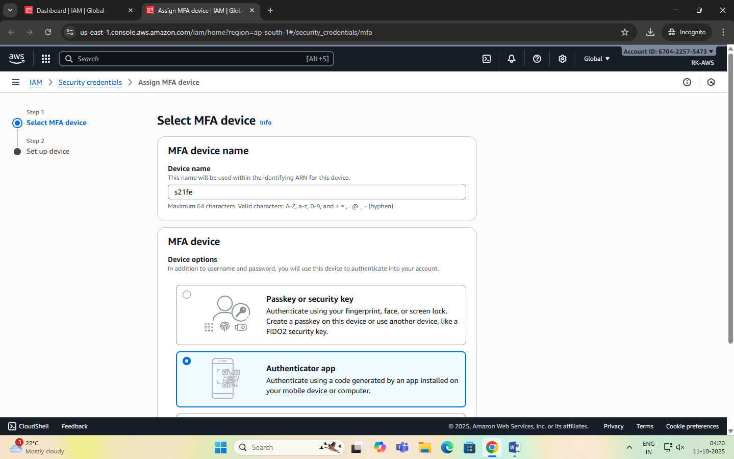

1. Select **“Authenticator app”** → **Next**.
2. A QR code appears.

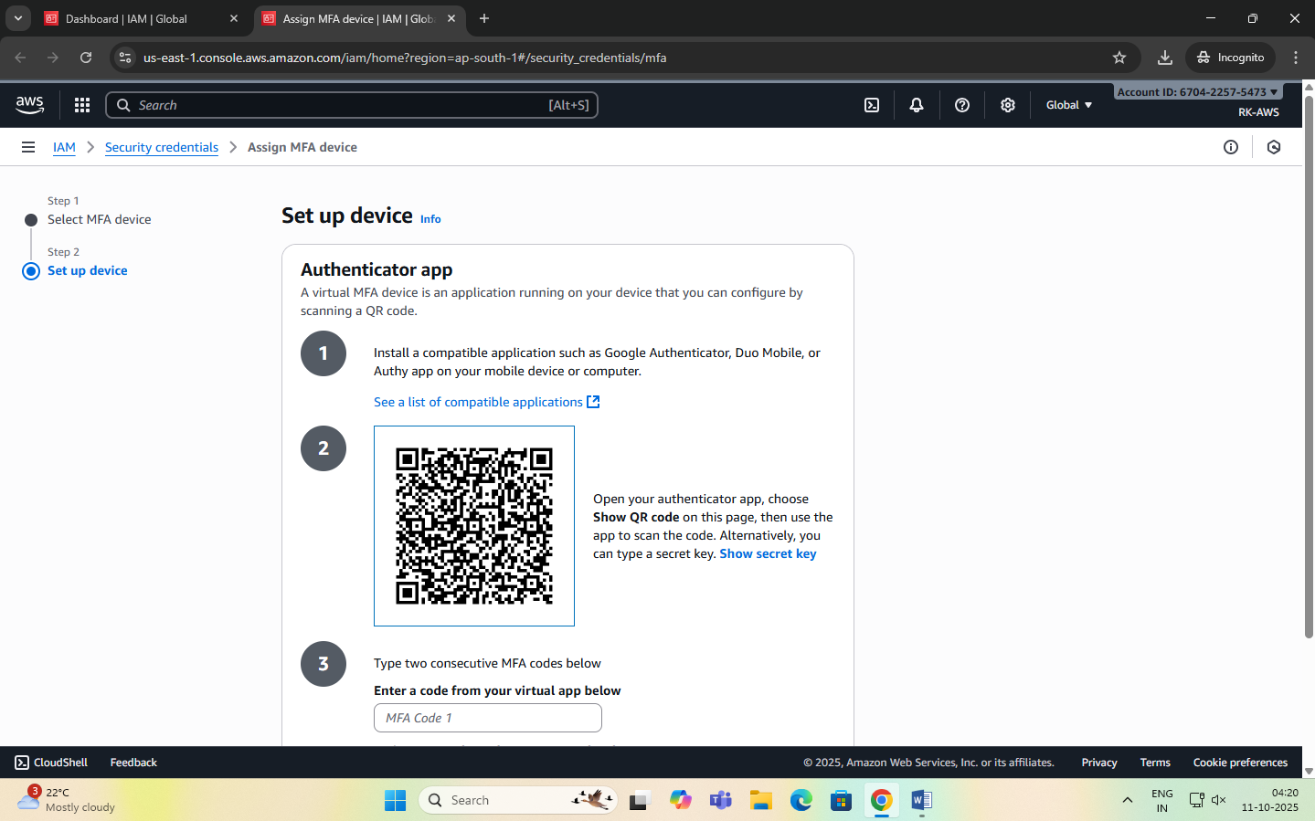

1. Open your authenticator app on your phone → **Add account → Scan QR code**.
2. The app shows a 6-digit code.
3. Enter that code back in AWS → **Assign MFA**. You’ll use the 6-digit code from the app each time you log in.

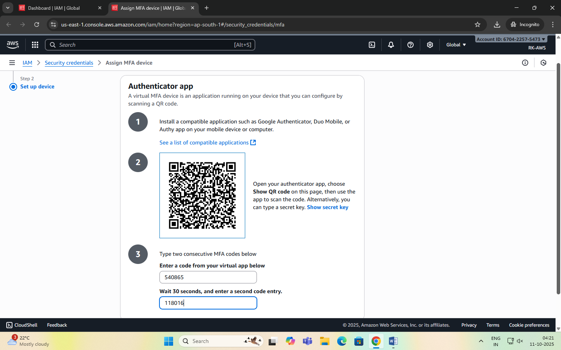

Create AWS budget alert

Allows to create a simple budget and to send alarms to registered email.

Example: if you are close to or exceeding your designated budget.

By setting a budget you can monitor budget threshold from the start.

Creating a budget

Step 1:

In the search bar type budgets and under the search results:

Select ‘Budgets’ from the Features group, which is essentially a feature of Billing and Cost Management service.

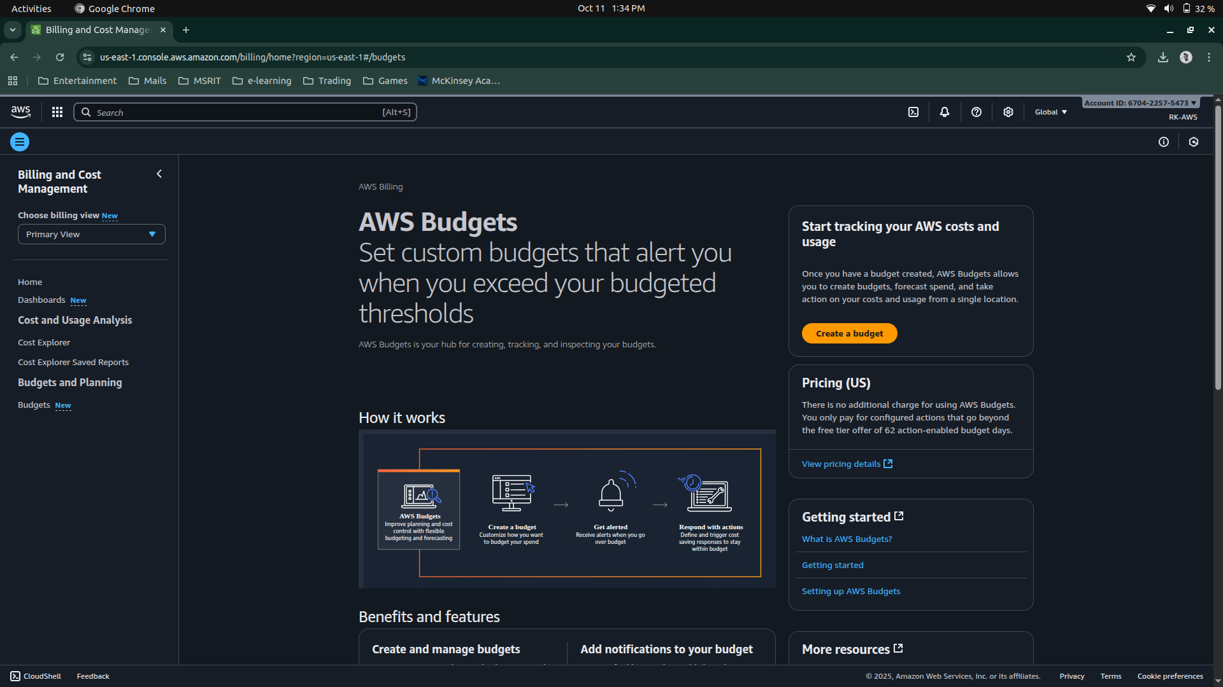

Step 2: After the ‘Budgets’ page loads

Click on Create Budget button

Under Budget setup select ‘Customize’ option

Under Budget types select ‘Cost budget’ option

Click on Next button.

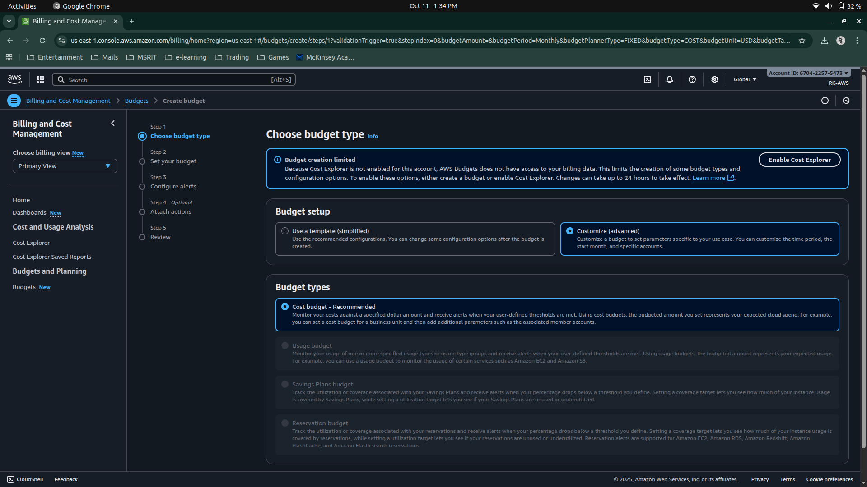

Step 3: Set your budget page loads and fill in the details: MyBudget, Monthly, Recurring budget, set Month and Year, select Fixed – Budgeting method - Enter your budgeted amount – 20.00, select ‘All AWS services’ Scope options. Advanced options – leave it on default.

Click on Next button.

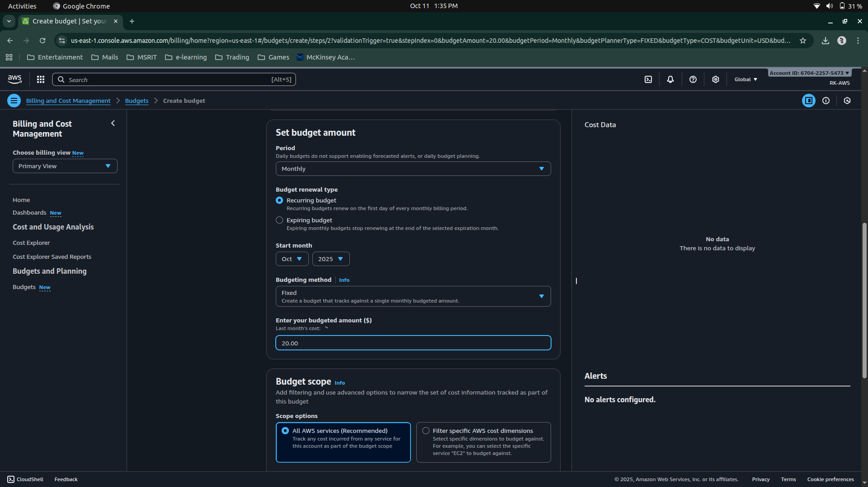

Step 4: Configure alerts

Click on Add an alert threshold

Under Set alert threshold

Set Threshold: 80 and Trigger: Actual

Email recipients: enter your email id.

Click on Next button.

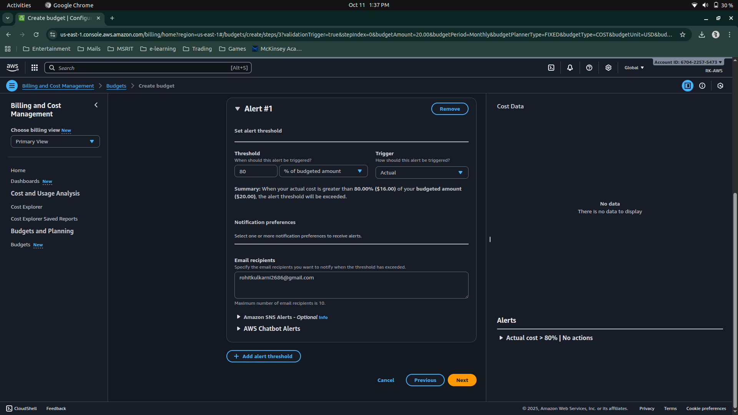

Step 5: Under Attach actions – leave it on default

Click on Next button.

Step 6: In review page – check and review all the options are set to what is desired.

Click on Create budget button.

Now, the budget has been created.

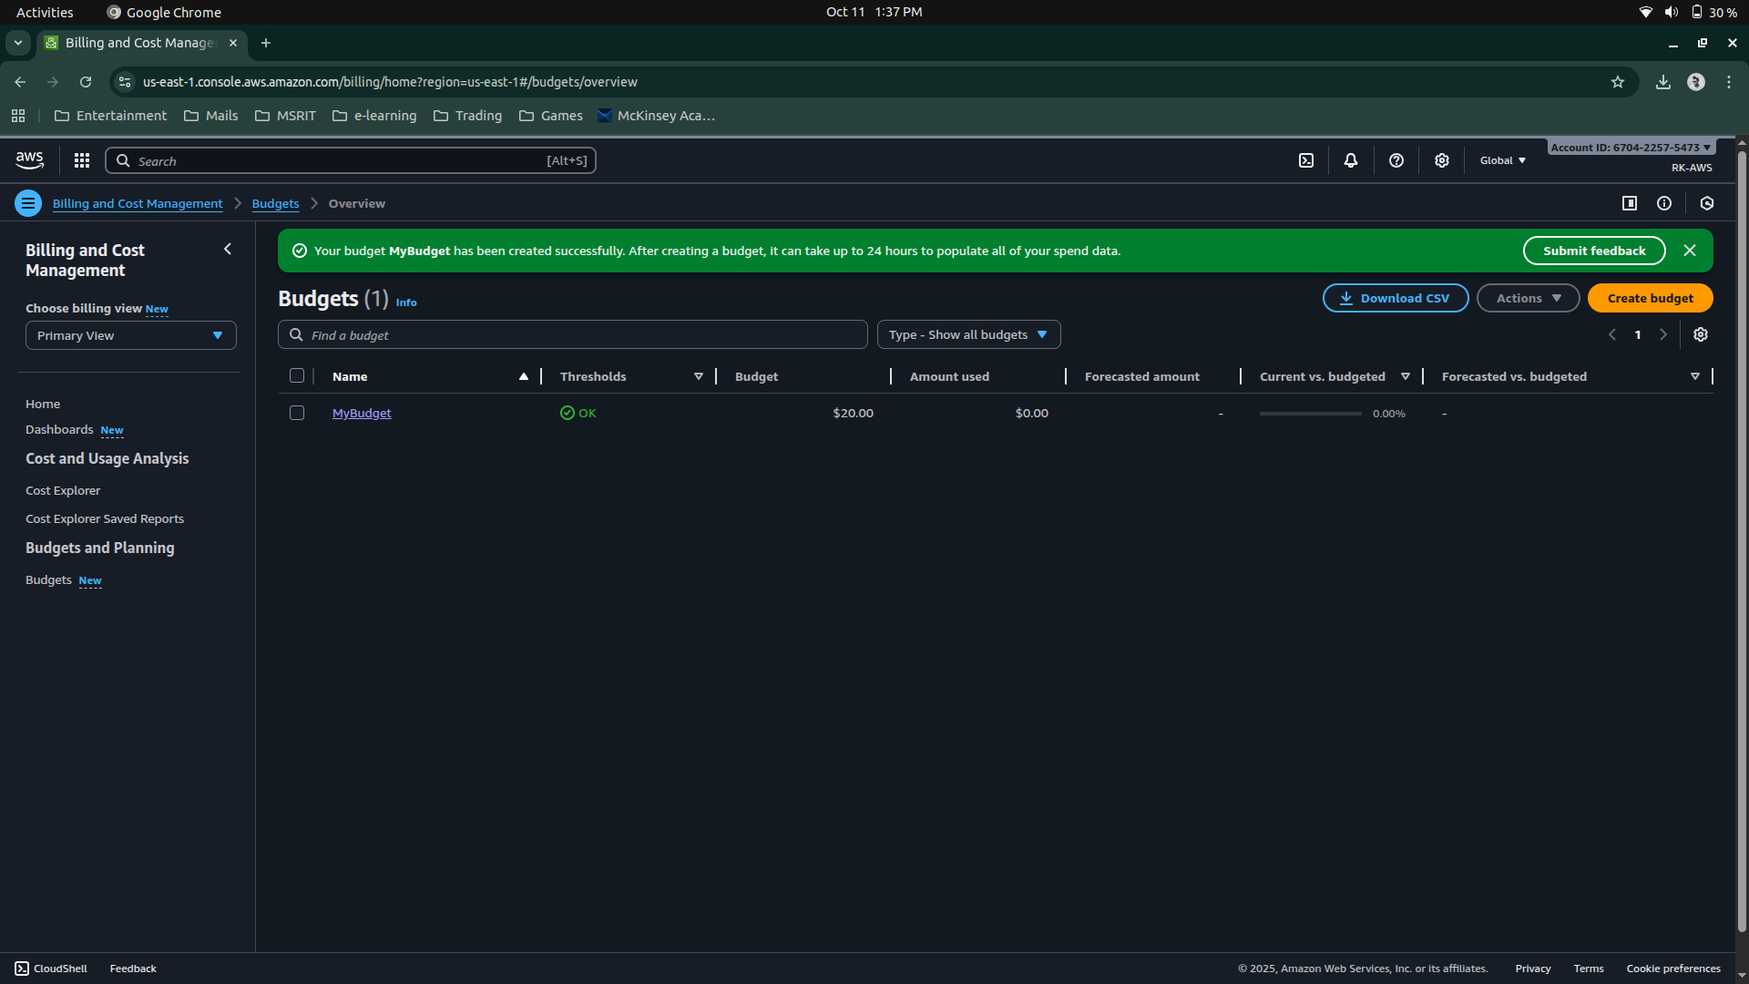

**Date: 9-10-2025**

**Exercise:** AWS Identity Access Management (IAM) User and Group creation. Enable AWS IAM MFA. Create an AWS Account Alias (for Alternate Sign-in URL)

AWS Identity and Access Management (IAM) is a security service that helps you control who can access your AWS resources and what actions they can perform. It is a global AWS service.  
It allows you to securely manage users, groups, roles, and permissions in your AWS account.

|  |  |
| --- | --- |
| Concept | Description |
| Root User | The account owner who created the AWS account. Has full access and should be used only for account setup. |
| Group | A collection of IAM users that share the same permissions. For example, a “Developers” group or “Students” group. |
| User | A person or application that interacts with AWS (e.g., student1, admin, developer). Each user has its own username, password, and access keys. |
| Policy | A JSON document that defines what actions are allowed or denied (e.g., “allow S3 read access”). |
| Role | A set of permissions that can be temporarily assumed by a user, service, or application — often used by EC2 instances or Lambda functions. |

**STEPS for AWS IAM User Group Creation**

**Step 1: Sign in to AWS Console**

* Log in to your AWS Management Console using an administrator account.
* From the Services menu, search for IAM and open it.

**Step 2: Open Groups Section**

* In the IAM dashboard, look at the left sidebar.
* Click on “User groups” → then click “Create group”.

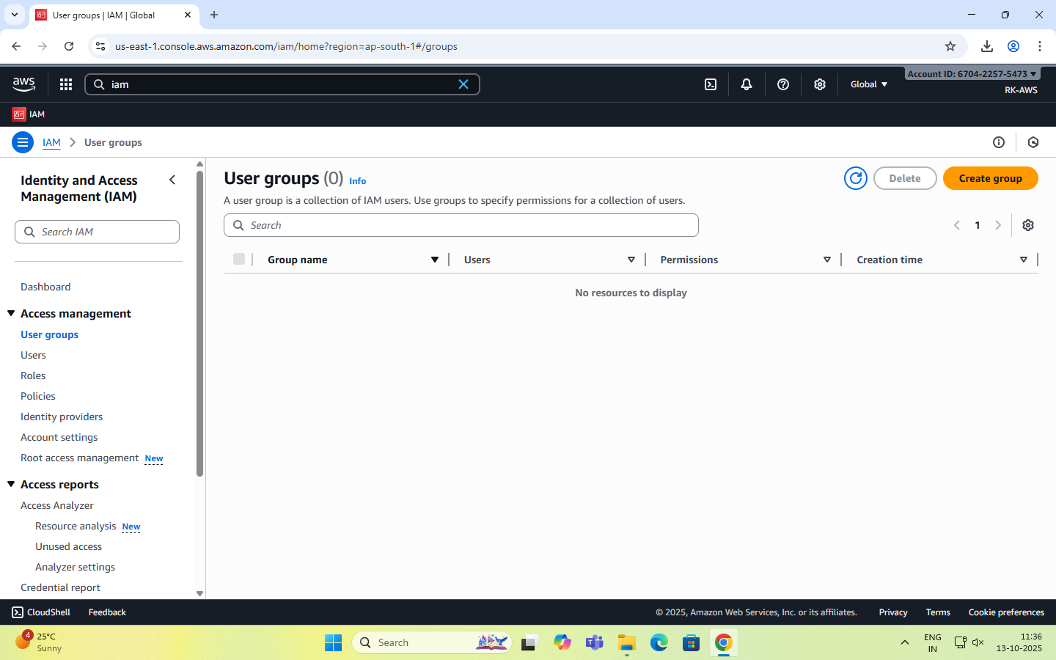

**Step 3: Name the Group**

* Enter a Group name (example: Developers, Admins, Students, etc.).
* Group names must be unique within your account.

**Step 4: Attach Permissions Policies**

* You can attach IAM policies to define what members of the group can do.  
  Select the following:
  + AdministratorAccess → Full access to all services.
  + IAMUserChangePassword

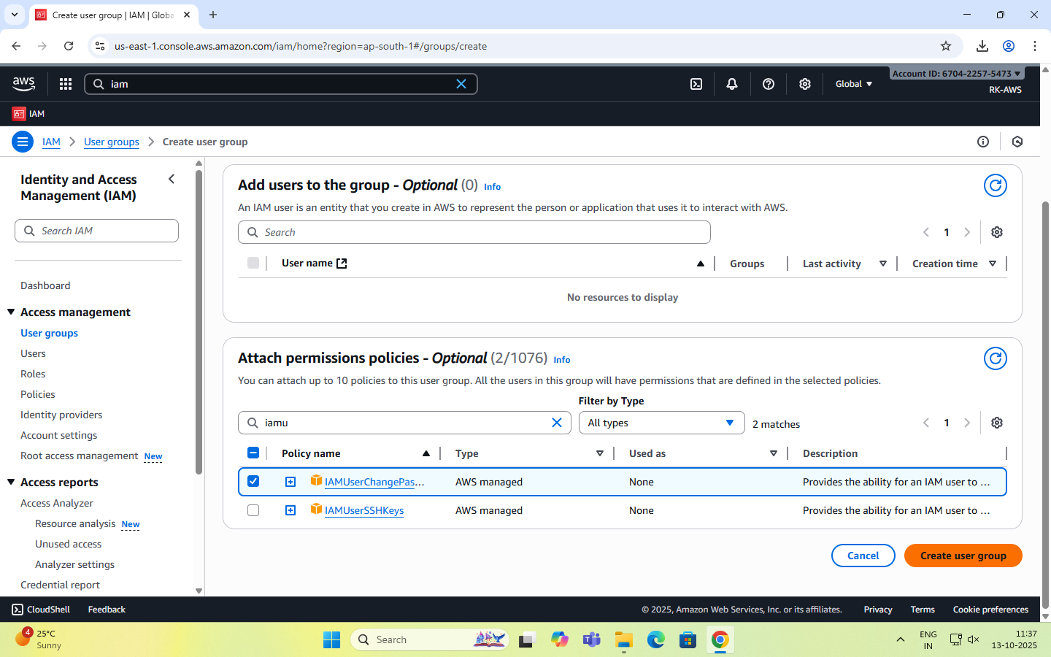

**Step 5: Review and Create**

* Review all details (group name + permissions).
* Click “Create group” to finalize.

**Step 6: Group Successfully Created**

* The new group now appears in the IAM dashboard.
* Any user added to this group automatically inherits all permissions attached to the group.

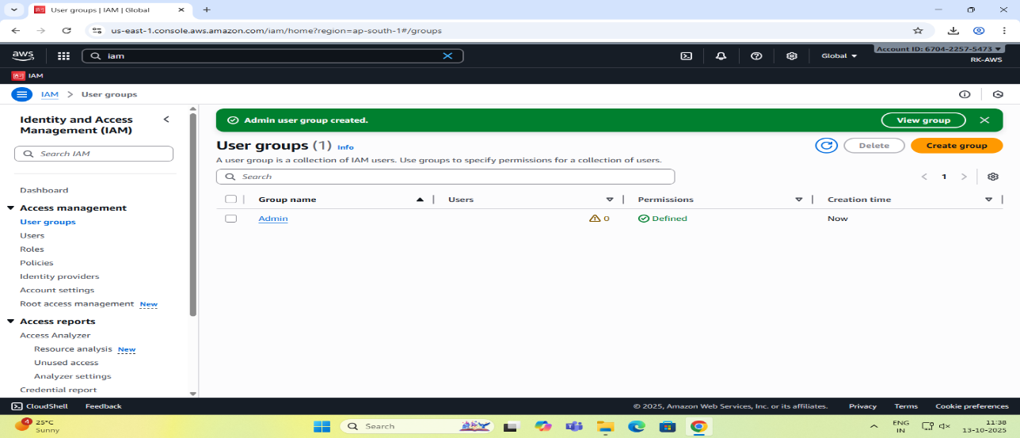

**STEPS for AWS IAM User Creation**

**Step 1: Sign in to AWS Management Console**

* Login to the AWS Management Console using your root user credentials.
* In the search bar, type IAM and open IAM service.

**Step 2: Navigate to Users Section**

* In the IAM dashboard’s left panel (info panel), click on Users.
* Then click on the “Add users” button.

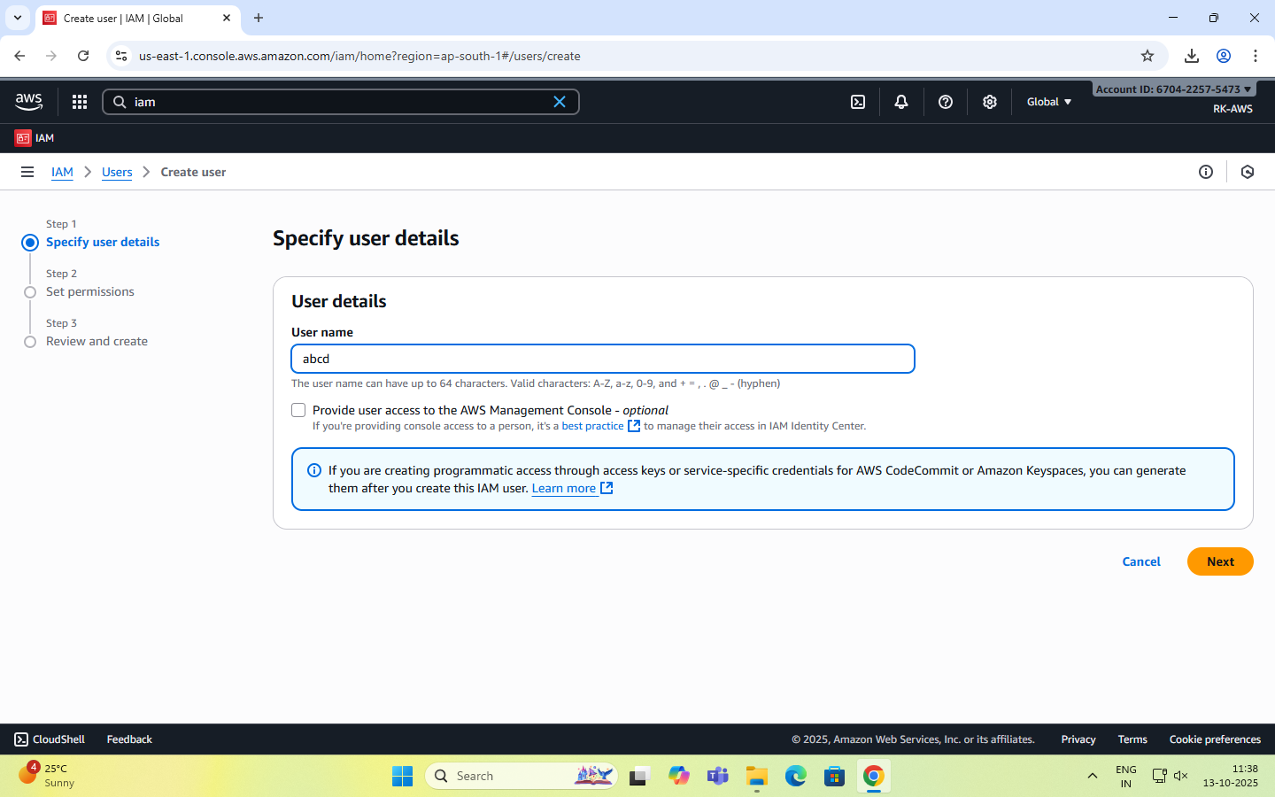

**Step 3: Set User Details**

* Enter a user name.
* Checkbox – ‘Provide user access to the AWS Management Console’.
* Select ‘I want to create an IAM user’ option

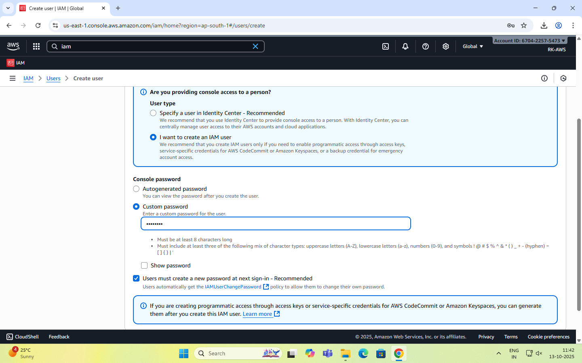

**Step 4: Set Permissions**

You can grant permissions to the new user in three ways:

1. Add user to group – Assign predefined permission groups.
2. Copy permissions from an existing user.
3. Attach existing policies directly.

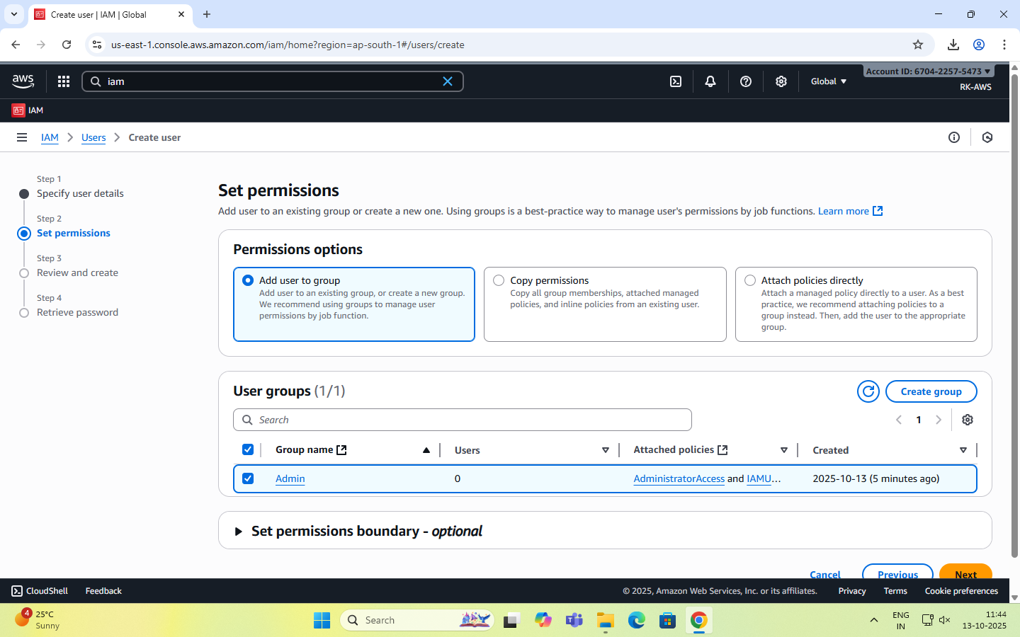

Recommended: Use IAM **groups** to manage permissions easily.

**Step 5: Set User Details and Tags (Optional)**

* Add tags like Department: MCA or Role: Faculty/Student for easy identification.
* Click Next to review.

**Step 6: Review and Create User**

* Review all settings (user name, permissions, tags).
* Click Create user.

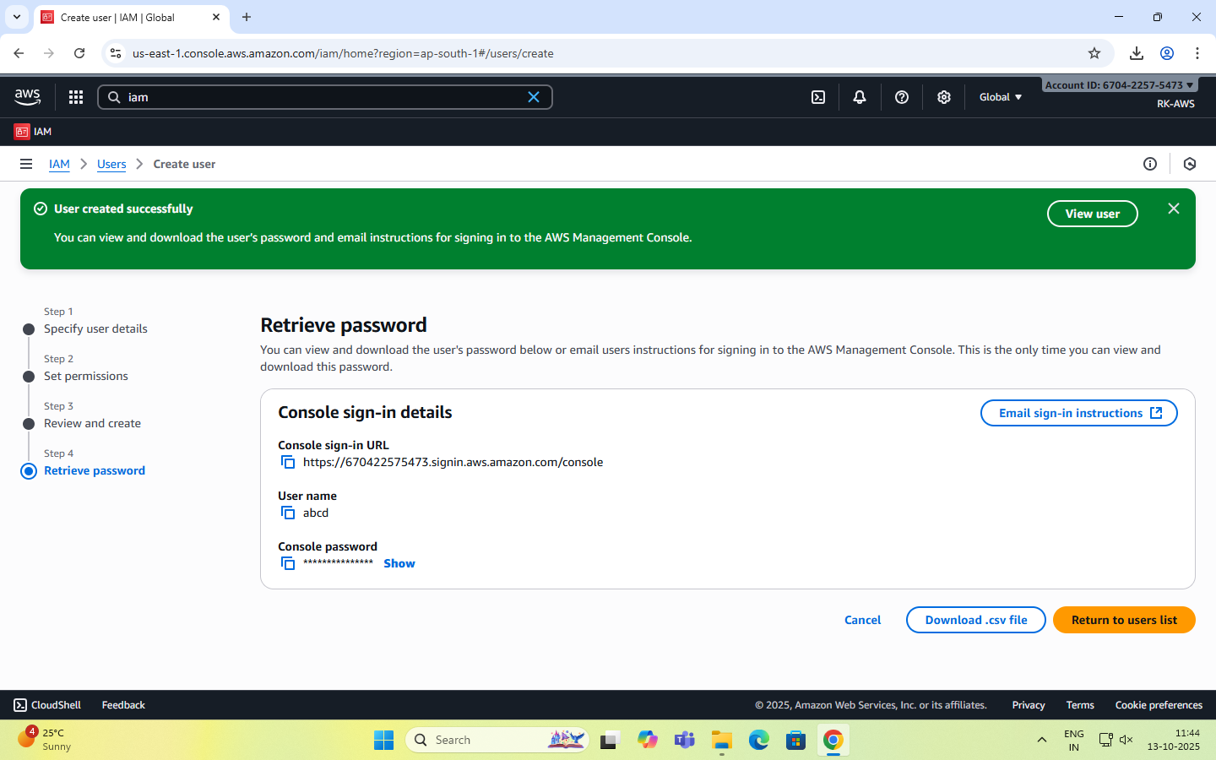

**Step 7: Save Credentials**

* After creation, AWS displays:

Console sign-in URL - <https://rohit2001.signin.aws.amazon.com/console>

Username -

Password –

Account ID- 670422575473

**NOTE:** Download or copy these credentials immediately — they cannot be retrieved later.

**Step 8: Test the User Login**

* Visit the IAM login URL provided (unique for your AWS account).
* Log in with the newly created username and password.
* Verify access and permissions.

Enable AWS IAM MFA

**Step 1:** Sign in to AWS Console as root user

**Step 2: Open IAM Dashboard**

* In the search bar, type IAM and select IAM (Identity and Access Management).
* From the left navigation pane, select Users.

**Step 3: Select a User**

* Click the user name for whom you want to enable MFA.
* This opens the User Summary page.

**Step 4: Go to Security Credentials Tab**

* Click the Security credentials tab.
* Scroll down to the section “Multi-factor authentication (MFA)”.

**Step 5: Assign MFA Device**

* Click “Assign MFA device”.
* Choose the MFA type:
  1. Virtual MFA device (e.g., Google Authenticator, Authy — most common)
  2. Security key (hardware-based, e.g., YubiKey)
  3. Authenticator app on phone

**Step 6: Configure Virtual MFA**

* If you select Virtual MFA device:
  1. Open your Google Authenticator or Authy app on your phone.
  2. Scan the QR code shown on the AWS screen.
  3. The app starts generating 6-digit codes.

**Step 7: Verify MFA**

* Enter two consecutive codes from your app in the verification fields.
* Click “Assign MFA”.

**Step 8: Confirm Setup**

* You will see a green checkmark confirming MFA is successfully assigned.
* The user now requires MFA each time they sign in.

Create an AWS Account Alias (for Alternate Sign-in URL)

As an IAM user you can sign in using the default URL or create an account alias for it.An Account Alias gives your AWS account a name instead of using the long numeric Account ID in your sign-in URL.  
This makes it easier for IAM users to remember and log in.

**Step 1:**

* Sign in to the AWS Management Console using root user or an IAM user with administrative privileges.
* In the search bar, type IAM, and open the IAM service.

**Step 2:**

* In the left navigation pane, scroll down and select Dashboard.

**Step 3:**

* Under the “AWS Account” section, find “Account Alias”.
* Click on “Create” (or “Edit” if one already exists).

**Step 4:**

* In the pop-up box, enter your preferred alias name.
* Click “Create alias”.

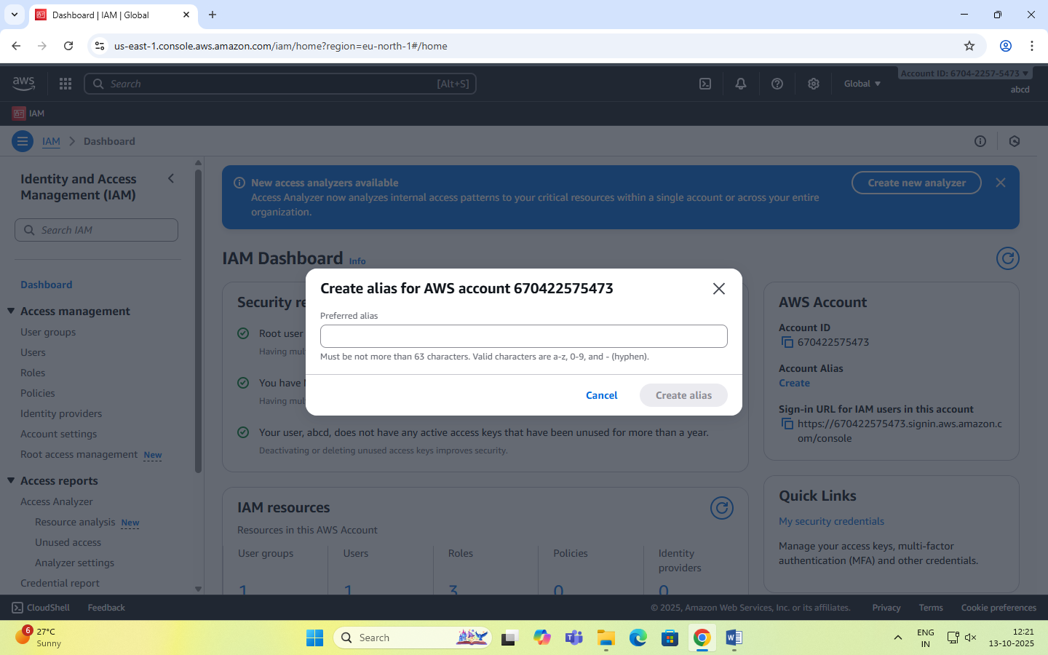

**Step 5:**

* Once created, you’ll see a new Sign-in URL displayed.

